2a-1 Total Cost of Ownership (TCO) Analysis

Class Activity Overview
This lab introduces the concept of Total Cost of Ownership (TCO) using printers as a scenario. Students will gather specifications and costs, define assumptions, and calculate the TCO of different printer models. They will then analyse and reflect on cost-based decisions in IT procurement.

Learning Objectives
- - Define TCO and identify components of fixed and variable costs.
- - Use spreadsheets to compare TCO across printer types (e.g., inkjet vs laser).
- - Make informed assumptions and document them clearly.
- - Evaluate decisions based on calculated TCO data.
- - Compare cost models for home vs business use cases.

Lab Instructions
- - Choose two printers to compare (e.g., budget inkjet vs office laser).
- - List all potential costs (fixed and variable). Examples: printer, cartridges, paper, power, service.
- - Define your assumptions: time period (5 years), weekly usage (750 pages), power on (40 hrs/week).
- - Use online sources (e.g., Officeworks, eBay, OEM manuals) to gather pricing and specs.
- - Calculate total quantity of consumables required for each printer over the chosen period.
- - Create or use a spreadsheet to total all costs (use formulas).
- - Compare final TCO values and reflect on the results.

Spreadsheet Components (Columns to Include)
- - Item Description
- - Type (Fixed/Variable)
- - Unit Price
- - Units Consumed (based on assumptions)
- - Total Cost (Unit Price × Units Consumed)

Example Assumptions to Use
- - Comparison period: 5 years
- - Pages printed per week: 750
- - Power usage per week: 40 hours
- - Cost of electricity per kWh: check local provider (e.g., $0.30)
- - Cost of paper (ream of 500): e.g., $6
- - Ink yield per cartridge: refer to specs (e.g., 500 pages)

Reflection Questions
- - Based on the TCO, which printer is the most cost-effective over 5 years?
- - Would the answer change for a home user who prints only 5 pages per week?
- - What other non-financial factors could influence printer selection?
- - What cost components are more significant for a large workgroup printer?
- - At what point (in years/pages) do the two printer options break even in cost?

💰 Activity: Total Cost of Ownership (TCO) Analysis – Printer Comparison
📘 Objective
To understand and apply the TCO methodology by comparing two printers over a specified period, incorporating fixed and variable costs, and interpreting the results for decision-making.

📦 Deliverables
# | Deliverable | Description
✅ 1 | Printer Models Chosen | Identify and list two printers with brand, model, and type (e.g., Inkjet vs Laser). State if they are:  • Entry-level home vs office-class printer  • Personal vs workgroup
✅ 2 | Cost Assumptions Documented | Clearly list all assumptions used in calculations:  • Period (e.g., 5 years)  • Pages printed per week (e.g., 750)  • Weekly runtime (e.g., 40 hrs)  • Lifespan of printer, cartridge yield, paper per ream, electricity rate
✅ 3 | List of Expense Items | Categorize into:  • Fixed costs (e.g., printer, extra accessories)  • Variable costs (e.g., paper, ink/toner, electricity, replacement parts)
✅ 4 | Unit Costs Sourced | Web links and sources for each item (e.g., from Officeworks, eBay):  • Printer price  • Ink/toner cost per unit  • Yield per cartridge  • Paper ream price  • kWh electricity rate
✅ 5 | Spreadsheet Calculation (TCO Model) | A well-structured spreadsheet with:  • Quantity × Unit Cost = Total per item  • Separate totals for fixed and variable costs  • Grand Total: Total Cost of Ownership (for 5 years) per printer
✅ 6 | Cost per Page Computed | Show TCO ÷ Total Pages = Cost per Page (e.g., $0.03/page) for each printer
✅ 7 | Break-even Analysis Table/Chart | Optional but encouraged: table or graph showing over time (e.g., 1–10 years) where the TCO for both printers becomes equal
✅ 8 | Reflection Questions Answered | Written response addressing:
→ Which printer has lower TCO and why?
→ Would the choice change if only 5 pages/week were printed?
→ What other qualitative or intangible factors could be considered (e.g., print speed, brand support, reliability)?
→ For a large workgroup printer, what cost/performance specs would you now prioritize?
→ Estimate the breakeven time point where both printers cost the same.
✅ 9 | Optional: Sensitivity Analysis | Explore what happens when:
• Pages/week increase or decrease
• Toner/paper costs fluctuate
• Energy costs rise (optional but insightful)

📝 Suggested Submission Format
- .zip file containing:
  - TCO spreadsheet (.xlsx, .ods, or .csv)
  - Cost assumption list (assumptions.txt or .md)
  - Written reflection (reflection.docx, .md, or .txt)
  - Screenshots or sources of unit prices (printer, ink, paper, etc.)

Office Printer
Model Name: HP Color LaserJet Pro MFP 3303fdw Printer
Price: SGD $809.00
Type: LaserJet
Printer Lifespan: Est. 10 years
Duty Cycle: 40,000 pages/month
Recommended monthly volume: 40,000 pages/month
Black toner yield: ~1,300 pages
Color toner yield: ~1,200 pages
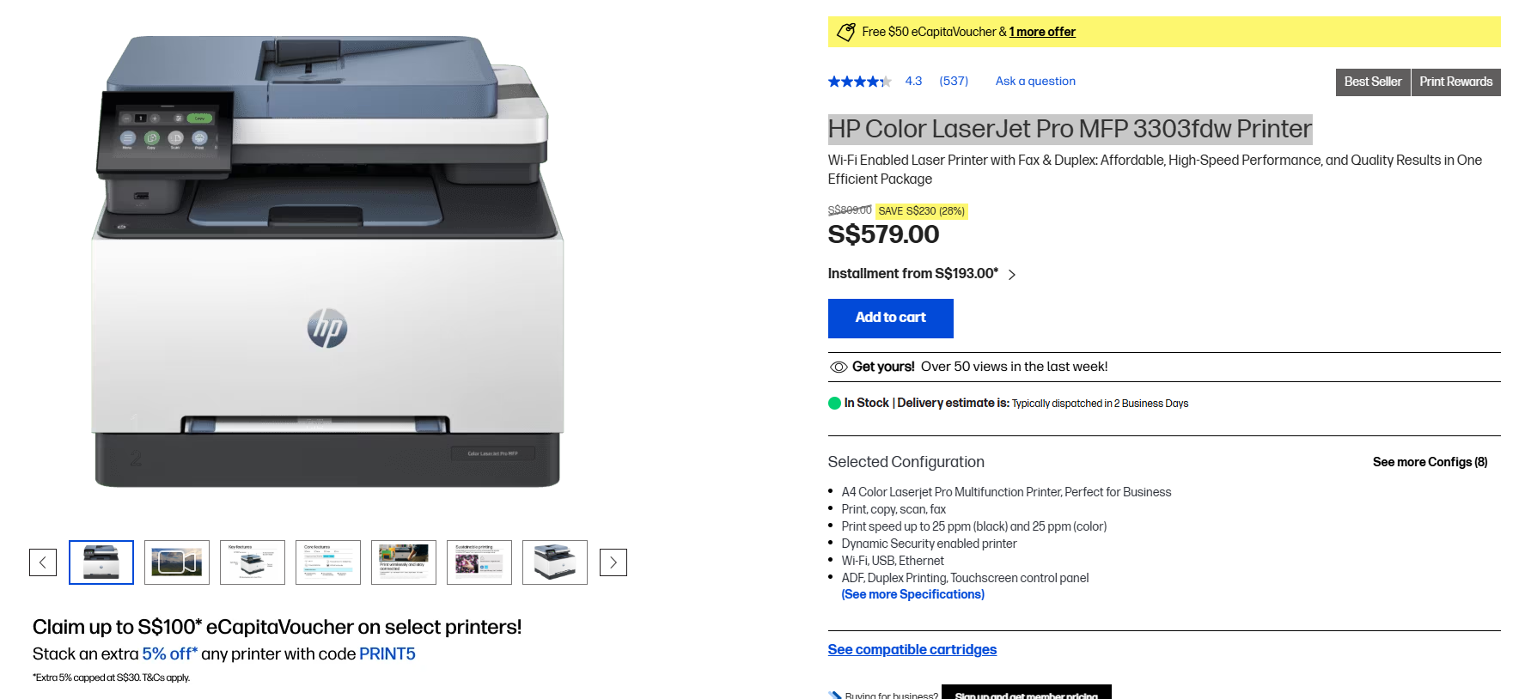
Home Printer
Model Name: Canon PIXMA G3770
Price: SGD $349.00
Type: InkJet
Printer Lifespan: Est. 5-7 years
Duty Cycle: 3,000 pages/month
Black ink yield: 6,000 pages (standard) / 7,600 pages (economy mode)
Color ink yield: 7,700 pages each (standard) / 8,100 pages (economy mode)
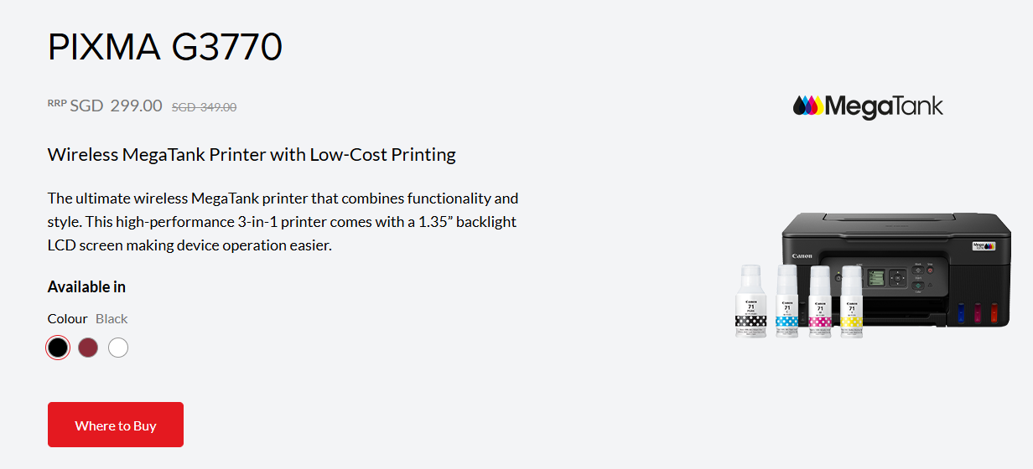
Printer Paper from Challenger
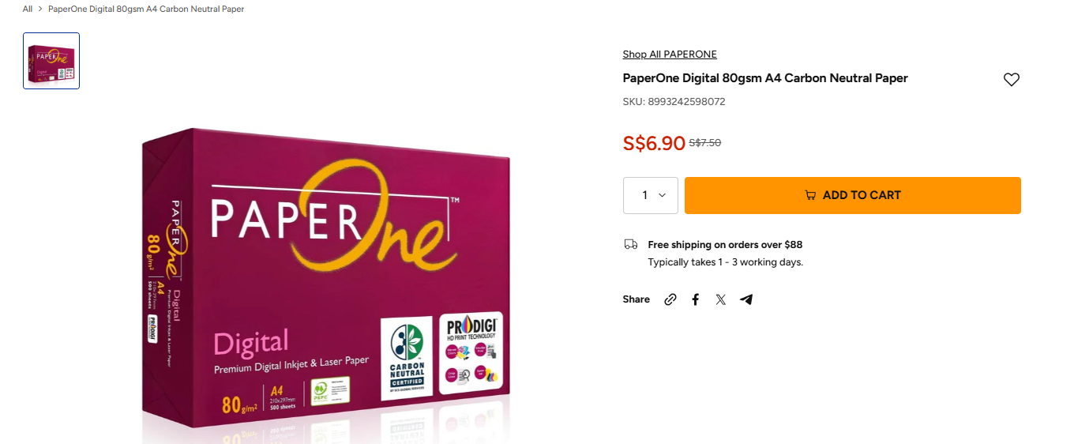
SGD $7.50

Electricity rate in Singapore
34/78 cents/kWh
Same charges apply for both printers
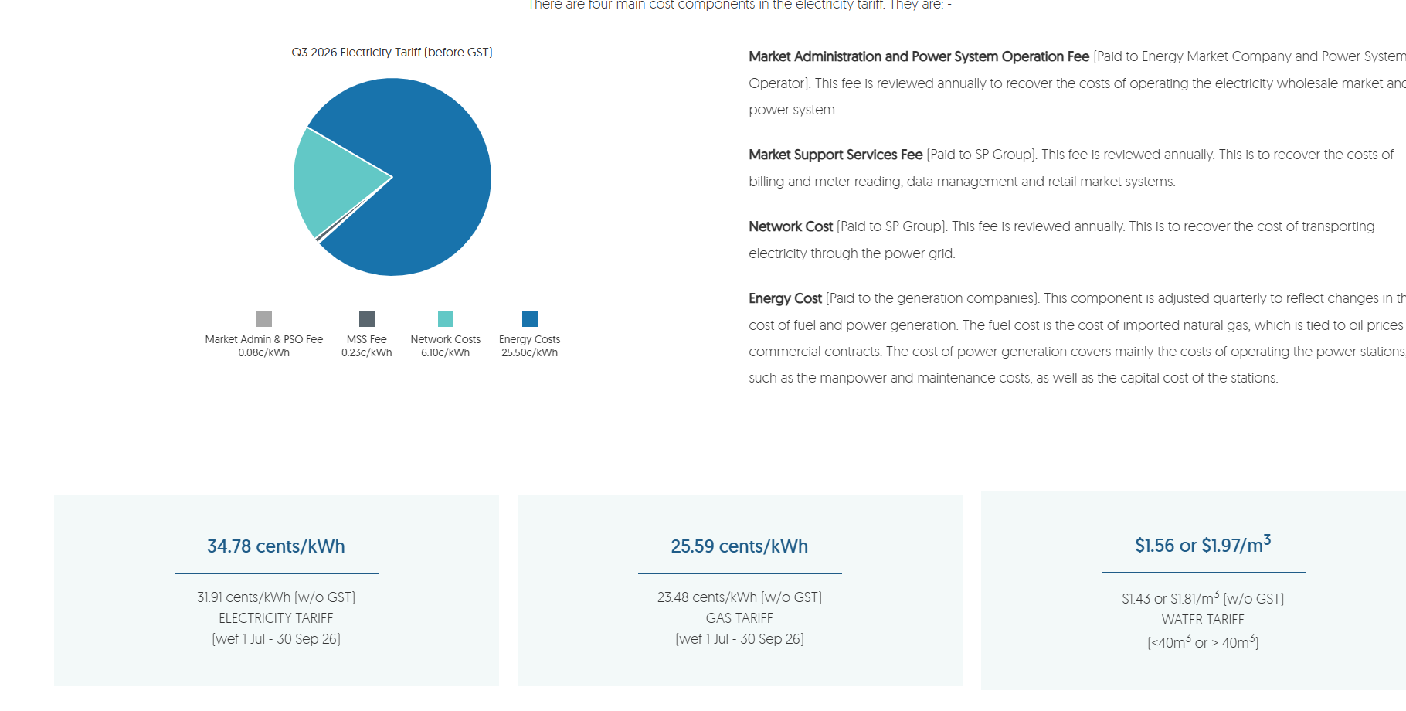
Unit Costs Sources:
https://sg.canon/en/consumer/pixma-g3770/black/product
https://www.hp.com/sg-en/shop/hp-color-laserjet-pro-mfp-3303fdw-499m8a.html
https://www.spgroup.com.sg/our-services/utilities/tariff-information
https://www.hp.com/sg-en/shop/ink-toner/toner.html
https://sg.canon/en/consumer/pixma-g3770/black/tco

Assumptions:
• Comparison period: 5 years
• Pages printed per week: 750
• Power usage per week: 40 hours
• Cost of electricity per kWh: 34/78 cents/kWh
• Cost of paper (80g/m2): [same for both printers]
- Total pages over a 5-year period:
  - 750 pages/week × 52 weeks/year × 5 years = 195,000 pages
- Reams needed:
  - 195,000 pages ÷ 500 sheets/ream = 390 reams
- Paper cost (using your original price, S$7.50/ream):
  - 390 reams × S$7.50 = S$2,925.00 — same for both printers
• Ink yield per cartridge: refer to specs (e.g., 500 pages)
- Canon:
  - 7,700 pages (color)
  - 6,000 pages (black)
- HP:
  - ~1,300 pages (black and color)

Reflection Questions
Based on the TCO, which printer is the most cost-effective over 5 years?
Based on the TCO, the Canon Pixma is more cost-effective because the total TCO over 5 years is $4,155.45, which is $36,247.63 less than the HP Printer
Would the answer change for a home user who prints only 5 pages per week?
Because the printer takes up lesser electricity when it sits indle, compared to when it is used for printing, and printing, ink and electricity costs will go down if the printer is only used to print 5 pages a week. However, the answer will not change, and the Canon printer will still be the more cost-effective due its smaller upfront cost, regardless of variable costs.

What other non-financial factors could influence printer selection?
- The years of warranty that come with each printer – different companies and printer type, different amounts of warranty
- Speed – how fast does the printer take to print one page? (Assume we print double-sided)
- Reliability – how long can the printer last without needing repairs/servicing if it used for 5 years? For example, does the printer require repairs every year because it breaks down easily?
- Environmental impact – carbon footprint of the printer – does it consume a lot of electricity even when it’s idle? Are the print cartridges recyclable?

What cost components are more significant for a large workgroup printer?
At high print volumes, variable costs — particularly toner cartridges and electricity — become far more significant than the fixed printer purchase price. For the HP printer, toner (both black and color toners) alone accounts for $36.050.70 of its $40,403.08 total 5-year TCO, compared to just $809 for the printer itself, because the color cartridges are expensive (~$116.70 each) and are consumed quickly at this volume. This shows that for a large workgroup printer, ongoing consumable and running costs — not the upfront hardware price — should be the priority when evaluating cost-effectiveness.

At what point (in years/pages) do the two printer options break even in cost?
The upfront cost of the HP printer costs $460 more than the Canon printer and the HP printer costs more per page as well. According to my calculations, each year, the cumulative cost of the HP printer per year is significantly more than the cumulative cost of the Canon Printer. Therefore, there is no point within the 5 year assumption that the two printer options break even in cost.

